November 29, 2022 Severe Weather Outbreak

By: Don Wheeler, Meteorologist

Synopsis and Overview

Figure 1 - PDS Tornado Watch 11/29/2022
URGENT - IMMEDIATE BROADCAST REQUESTED
Tornado Watch Number 572
NWS Storm Prediction Center Norman OK
1210 PM CST Tue Nov 29 2022

The NWS Storm Prediction Center has issued a

* Tornado Watch for portions of
Southeast Arkansas
Northern and Central Louisiana
Central Mississippi

* Effective this Tuesday afternoon and evening from 1210 PM until
700 PM CST.

...THIS IS A PARTICULARLY DANGEROUS SITUATION...

Tornado watch number 572 was the first of several watches issued on November 29 and 30, 2022 in anticipation of a significant severe weather outbreak across the Deep South. This tornado watch was of more concern in that it contained the rare phrase, “This is a particularly dangerous situation.” A “PDS” watch is rare in that it makes up only about 7% of all tornado watches (Dean & Schaefer – Storm Prediction Center).

According to the Storm Prediction Center,

The "Particularly Dangerous Situation" wording is used in Tornado Watches for rare situations when long-lived intense tornadoes are likely. This enhanced wording may also accompany Severe Thunderstorm Watches for widespread significant severe events, usually produced by exceptionally intense derechos. PDS watches are issued, when in the opinion of the forecaster, the likelihood of significant events is boosted by very volatile atmospheric conditions. Usually, this decision is based on a number of atmospheric clues and parameters, so the decision to issue a PDS watch is subjective with no hard criteria. However, the SPC goal is to have 3 out of every 4 PDS Tornado Watches verifying with multiple intense tornadoes. PDS watches are most often issued with a High risk in Day 1 Convective Outlooks.

Preliminary storm reports for the November 29 event indicate there were 66 reports of tornado damage (some of these reports were from the same tornado), 43 hail/significant hail reports, and 146 winds/damaging wind reports. The totals indicate that there were 24 confirmed tornadoes stretching from Louisiana to Alabama with severe weather reports extending into Georgia. Seven of the 24 tornadoes were classified as being “strong” with a rating of EF2 (winds of 111-135 mph) or EF3 (winds of 136-165 mph). One of these EF3’s occurred in Caldwell Parish south of Columbia.

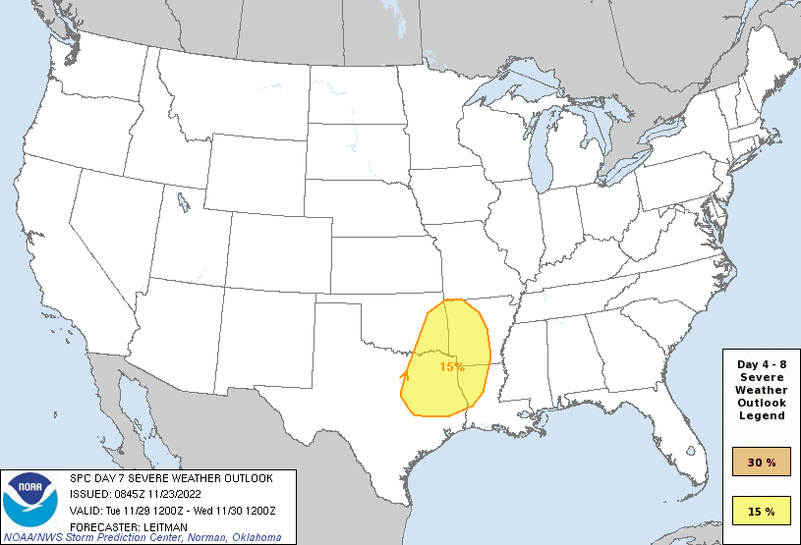
This system resulted in two fatalities and one injury in the Flatwood and Willow Springs communities in Alabama when a tree fell on a mobile home. An additional injury was also reported in the same area due to a mobile home being rolled. The only other injury reported with this system was with the EF3 tornado southeast of Clarks, Louisiana in Caldwell Parish.

Long-range computer models began to pick up on the potential for a severe weather outbreak across the Southern Plains a week prior to the event prompting the Storm Prediction Center (SPC) to begin advertising the potential on their extended Day-7 outlook map. Each day following the initial outlook, the target area shifted slightly farther to the east.
Figure 2 - Day 7 Severe Weather Outlook Issued on 11/13/2022

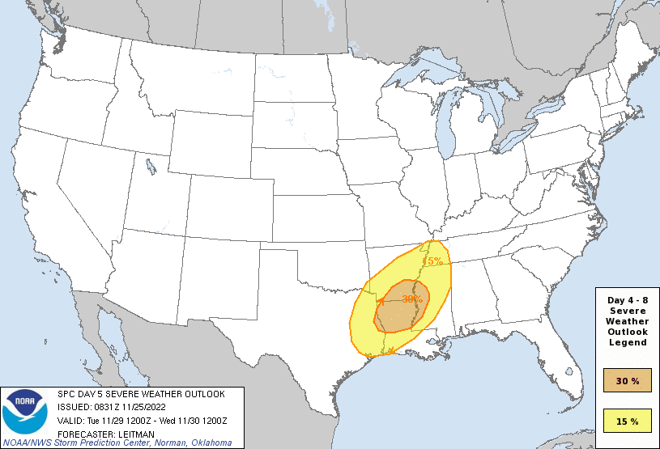
With each run, long-range models were becoming more consistent indicating that parameters were coming together for a potentially significant severe weather outbreak. Models were showing that a significant, vigorous upper-level trough would develop across the central and southern Rockies by Tuesday, November 29 inducing a number of parameters conducive to a severe weather outbreak. Closer to the surface, a strong low-level jet with winds in the 50-70 knot range would develop across east Texas and the southern Mississippi River Valley area advecting rich gulf moisture into the region. A strongly sheared environment was also forecast to develop with the approaching upper-level trough producing a 60-70 knot shear value in the 0-6 km range and helicity values of 400 to 500 m²/s² in the 0-3 km level. MLCAPE forecasts were in the 1500 to 2000 J/kg range. With the issuance of the first Day-3 outlook on November 27, an Enhanced Risk was posted for a good part of northeast Louisiana, eastern Arkansas, and northwestern Mississippi.
Figure 3- Day 5 Outlook Ahead of 12/29 Event

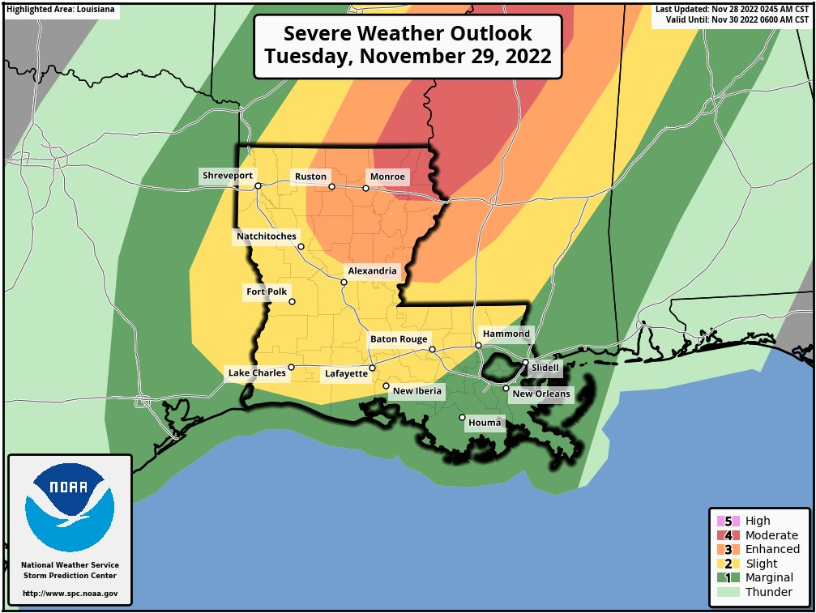
On November 28, the Day-2 outlook was more ominous as a portion of the prior day’s Enhanced Risk area was upgraded to a Moderate Risk – a 4 out of 5 on the severe weather risk category chart. The upgrade highlighted the potential for a few strong and long-lived tornadoes in and close to the Moderate Risk area. The SPC continued to slightly adjust the severe risk areas with each successive model run but the general areas of concern remain rather consistent.
Figure 4 - Day 2 Outlook for 12/29/2022

On the morning of Tuesday, November 29, a large upper-level trough was digging south across the Rockies into northern old Mexico. This feature was well depicted on the 700mb and 500 mb charts. At the surface an area of low pressure was noted over southern Manitoba, Canada with a cold front arching across Lake Superior and into the central Plains states, turning west across the Oklahoma and Texas Panhandles to a low in Colorado.

Further south, a warm front was moving north across south Louisiana. Behind the front was a surge of moist, unstable air from the gulf. This front would push north through the day into southern Arkansas and northern Mississippi exposing the forecast Moderate Risk area to the unstable air. The cold front to the northwest would make little in the way of southeastward progress during the day and would not play much in the role of the outbreak.

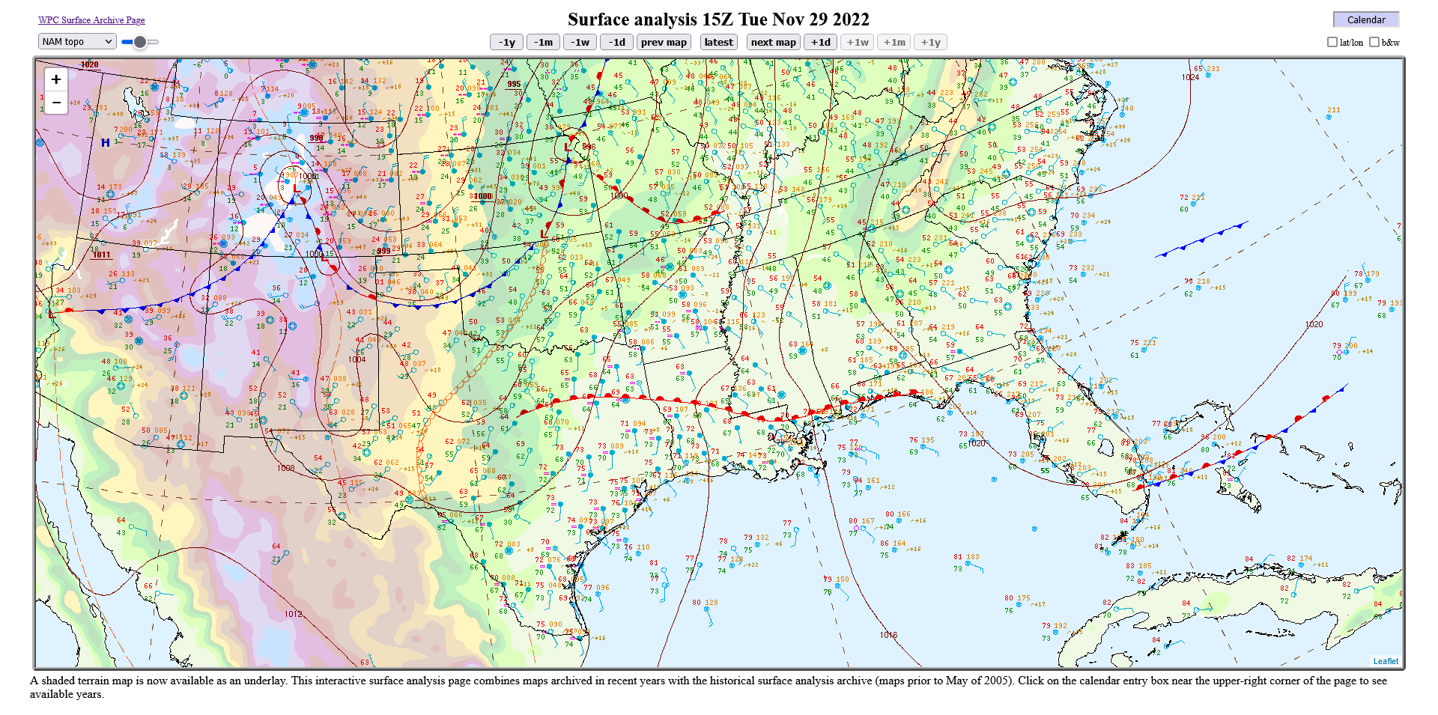
Figure 5- Surface Analysis 15Z 12/29/2022
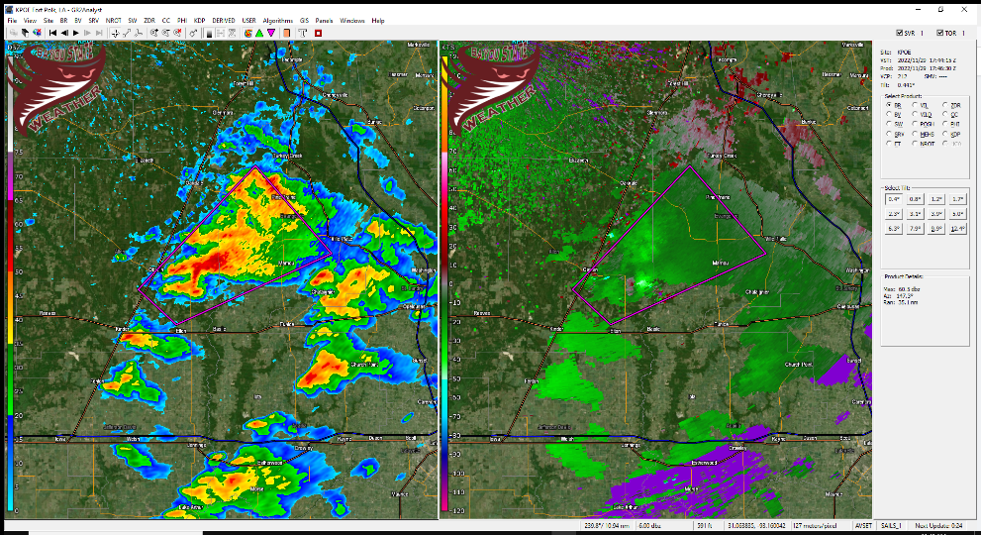
Storms began to develop across central and southern Louisiana during the late morning hours along and behind the advancing warm front. The first Tornado Warning of the day for Louisiana was issued at 11:42 AM for southwestern Evangeline Parish and Southeastern Allen Parish in southwest Louisiana. Radar was showing a possible tornado between Oberlin and Basile although no reports of an actual touchdown were documented. Shortly after, Tornado Watch #572 was issued by the SPC at 12:10 PM.
Figure 6 - First Tornado Warned Storm - South Louisiana

A small cluster of storms continued to move east-northeast out of southwest Louisiana across southcentral Louisiana shortly after the noon hour prompting additional tornado warnings. Like the initial storm over southwest Louisiana, no confirmed touchdowns were reported in the post-storm analysis although this cluster did eventually produce tornadoes over south Mississippi.

As the afternoon progressed, additional storms began to initialize across deep east Texas and the Toledo Bend area of west-central Louisiana. Storms also began to fire across southern areas of north Louisiana where an axis of training storms appeared to be setting up. This axis extended from northern Toledo Bend east-northeast into southern areas of northeast Louisiana to the Winnfield and Columbia areas and then into western Mississippi to the Vicksburg area. As storms developed during the afternoon, they trekked along this axis prompting several severe thunderstorm and tornado warnings.

A map depicting overlays of severe thunderstorm and tornado warnings clearly shows two primary axes of storm tracks. The first initiated during the late morning hours across southwest Louisiana into southwest Mississippi and then east-northeast into central Alabama. The second initiated during the early afternoon hours across western Louisiana into northeast Louisiana and then into central Mississippi. A tertiary axis also developed across northcentral Mississippi at
the onset of the severe outbreak during the morning hours. The two primary axes led directly into the heart of the Moderate and Enhanced risk areas.

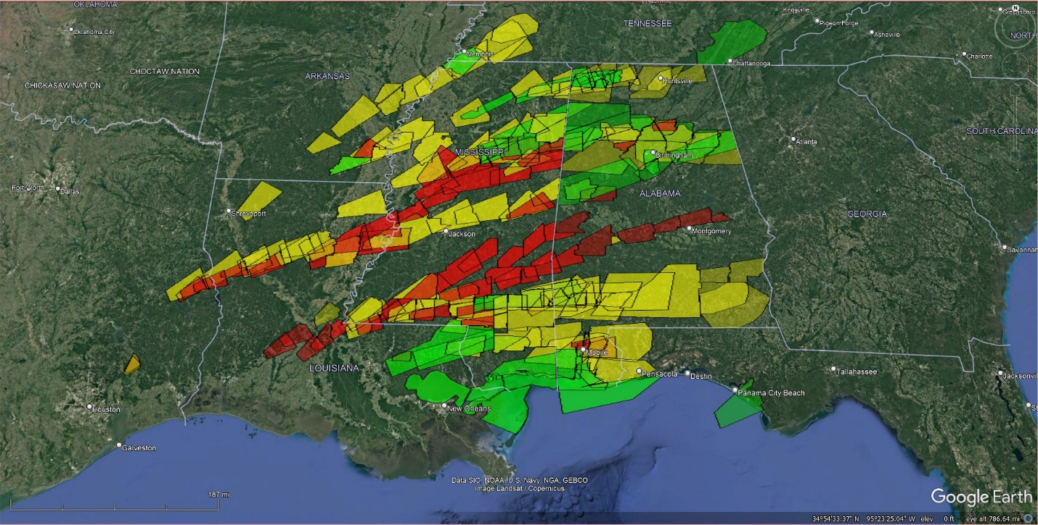
Figure 7- Tornado, Severe Thunderstorm, and Flash Flood Warnings Issued During the Event
Caldwell Parish Tornado

While some 16 tornado warnings were issued for Louisiana, only two tornadoes were confirmed. Both of these tornadoes, and EF-3 and an EF-U (unknown) were spawned from the same supercell thunderstorm that trekked across three states, traveling some 260 miles, while prompting tornado and severe thunderstorm warnings along its path.

The storm that produced the Caldwell and Madison Parish tornadoes began around 20:00Z/2:00 PM CST as two separate storms in deep east Texas. One storm was located approximately 40 miles southwest of San Angelo, Texas and the other to the east-southeast approximately 26 miles of San Angelo or near Zavalla, Texas. The southernmost storm near Zavalla, while not as robust in appearance as its neighbor to the north, actually developed a circulation on its southwest flank prompting a tornado warning to be issued at 2:36 PM while 16 miles south-southwest of San Augustine.

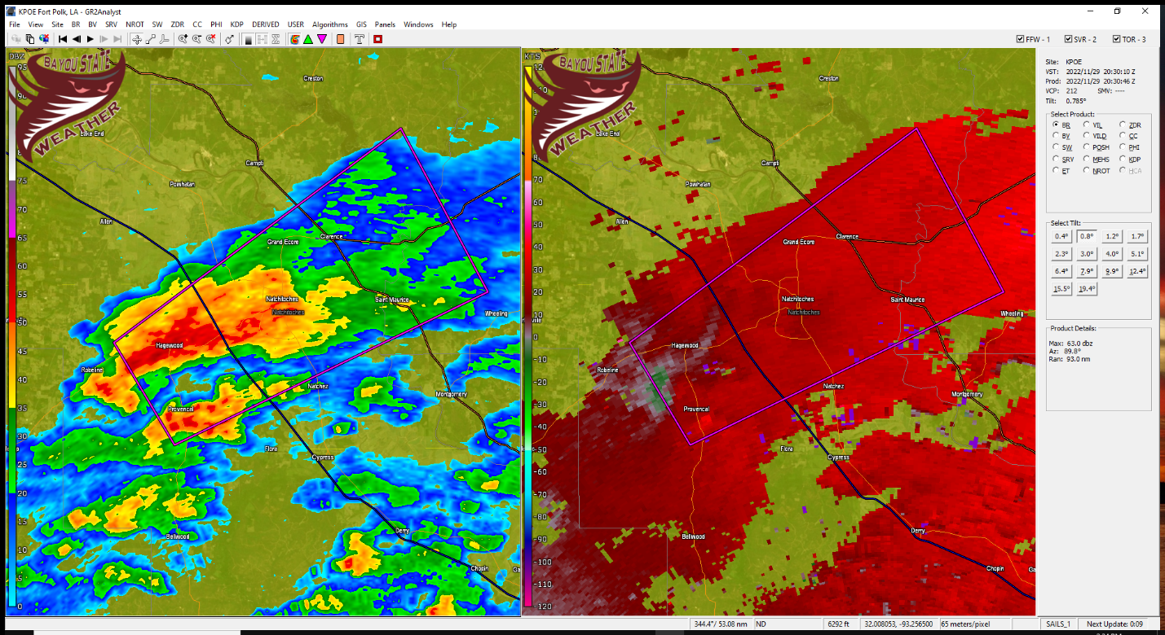
Figure 8 - Two Severe Storms About to Merge in East Texas
The lead tornadic storm took a path slightly to the northeast while the larger, non-tornadic storm marched east. The two storms merged around 2:45 PM at which time a new tornado warning was issued at 2:58 PM with the center of circulation near Macune, Texas.

The now merged storm continued to push on a northeast trajectory toward northern Toledo Bend but the rotation began to weaken. The tornado warning was replaced by a severe thunderstorm warning at 3:30 PM for DeSoto, Natchitoches, and Sabine Parishes as it entered northwest Louisiana with strong winds to 70 mph possible while racing to the northeast at some 60 mph.

By 22:20Z/4:20 PM CST, the storm began to reorganize with more noticeable rotation about seven miles southwest of Natchitoches. At 4:28 PM a tornado warning was issued for Grant, Natchitoches, and Winn Parishes with a circulation approximately 6.5 miles south-southwest of Natchitoches.

Once again, the storm cycled with the circulation weakening just to the south of Winnfield at 23:10Z/5:10 PM. The previously issued tornado warning was allowed to expire and was replaced by a severe thunderstorm warning. The weakening was rather short-lived as rotation intensified approximately four miles northwest of Tullos at 5:34 PM. The velocity signature became quite impressive and a new tornado warning was issued at 5:49 PM for Caldwell and LaSalle Parishes with a possible tornado near Olla moving northeast at 45 mph. The new tornado warning was classified as a “PDS” tornado warning, like its relative the PDS-Watch, designating the warning as a “Particularly Dangerous Situation.”

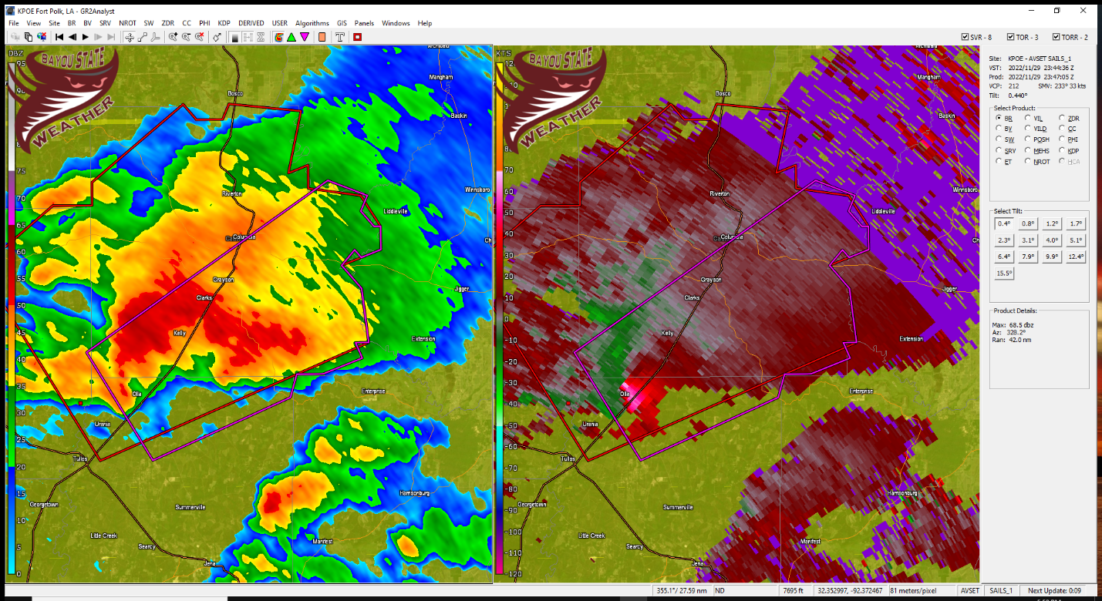
Figure 9 - Rotation Increasing near Olla, Louisiana in Northern LaSalle Parish - 2347Z
At 6:04 PM, a debris signature began to appear on the Ft. Polk radar (the closest radar to the tornado) which quickly developed a rather intense and unmistakable signature. Velocities at 6,300 feet were showing a gate-to-gate value of approximately 156 mph at this altitude. The maximum windspeed assigned to the tornado at surface level of 140 mph was estimated to be shortly after the onset of touchdown.

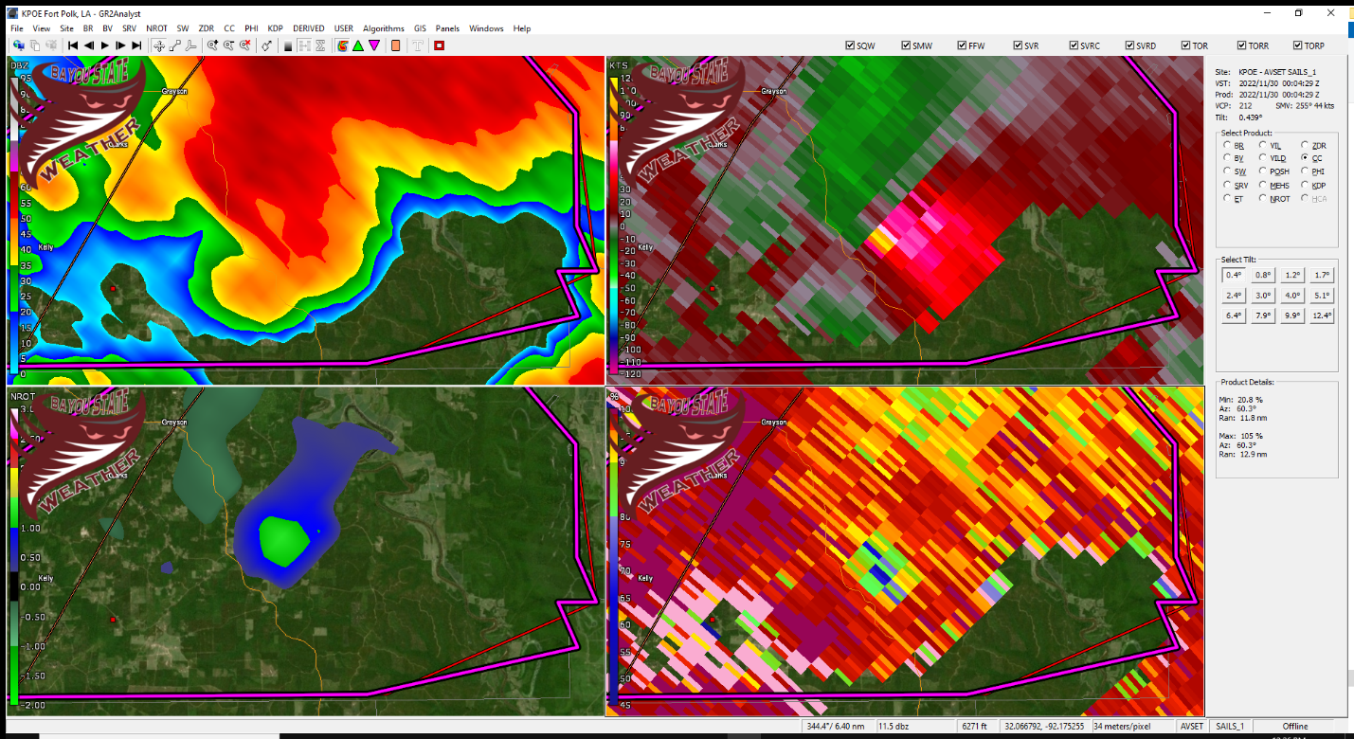
Figure 10 - Radar Showing First Indication of Debris in the Air Just Southwest of Grayson, LA at 0004Z

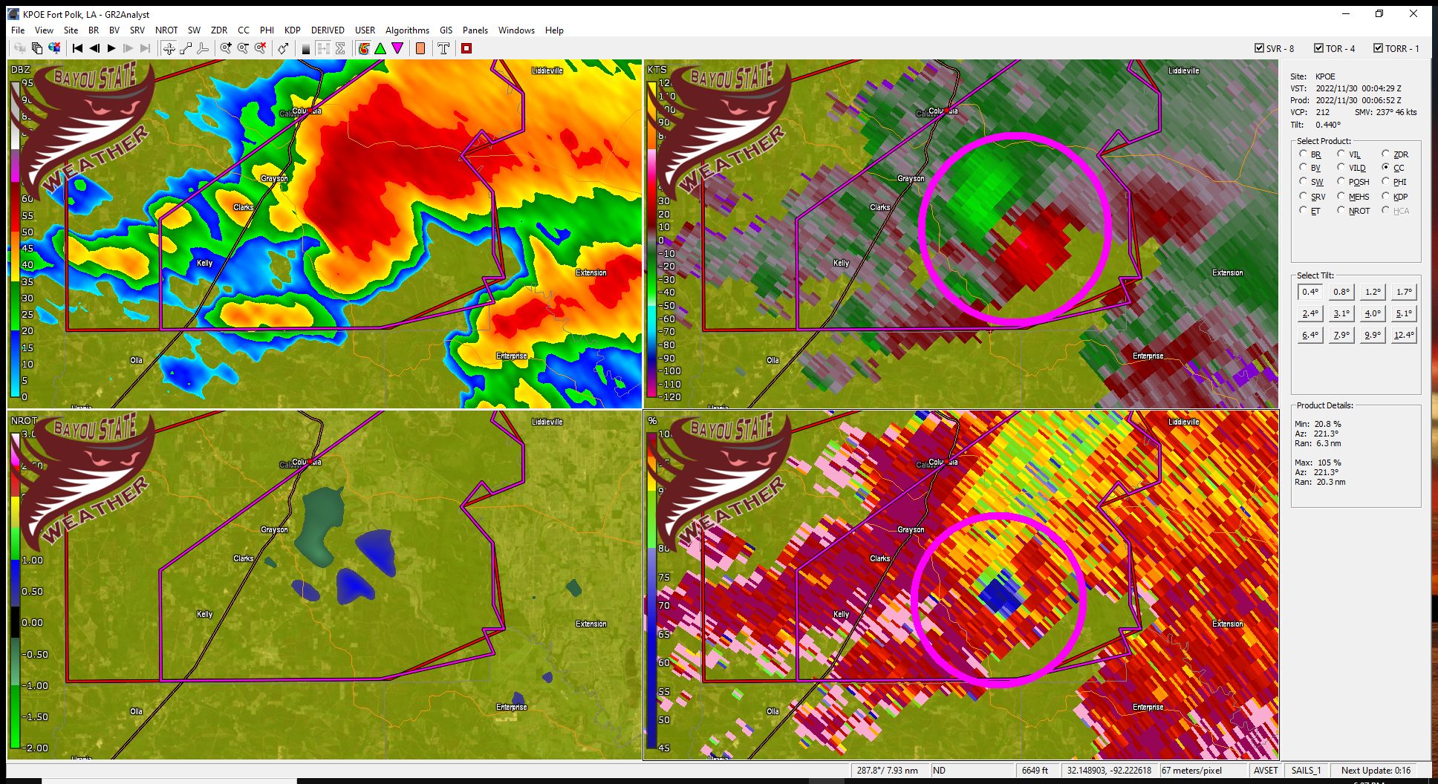
Figure 11 - Strong Debris Signature Southwest of Grayson, LA in Caldwell Parish at 0006Z

Below is the official preliminary summary from the National Weather Service in Shreveport which highlights the path and the damage incurred along it.

Rating: EF3
Estimated Peak Wind: 140 mph
Path Length/statute: 7.96 miles
Path Width/maximum: 300 yards
Fatalities: 0
Injuries: 1

Start Date: 11/29/2022
Start Time: 06:03 PM CST
Start Location: 5 SE Clarks/Caldwell Parish/Louisiana
Start Lat/Long: 31.9743/-92.0655

End Date: 11/29/2022
End Time: 06:13 PM CST
End Location: 9 SE Columbia/Caldwell Parish/Louisiana
End Lat/Long: 32.02/-91.94

Survey Summary:
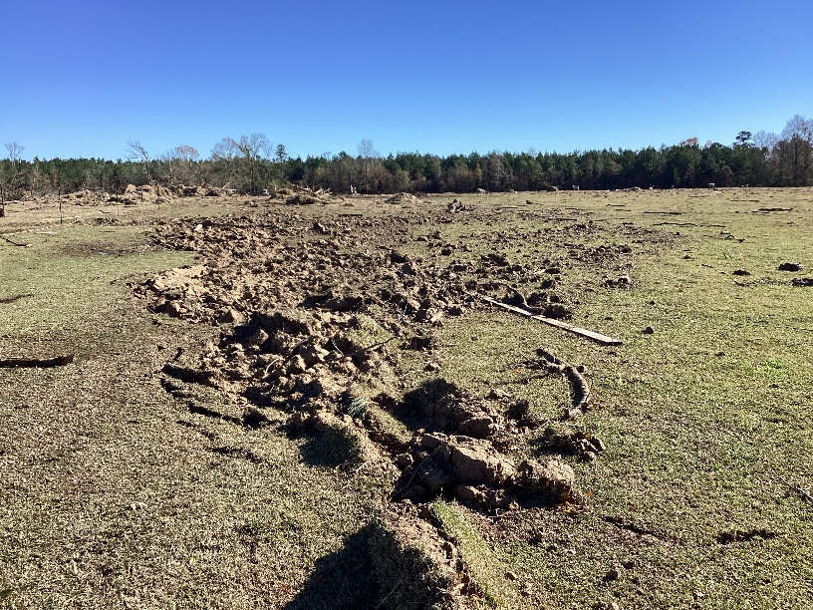
This strong tornado produced by a long-lived supercell thunderstorm first touched down along Highway 126 in rural southeast Caldwell Parish, just southeast of the Holum community. Interestingly, the most intense damage of the tornado occurred here as two residences were essentially destroyed. One residence was a one- or two-family residence which had its roof and most walls removed, including many interior walls collapsed. The one human injury of this tornado occurred here, but fortunately this was a non-critical injury. This damage was rated at a strong EF2. Another home, a single wide mobile home, was destroyed and this damage warranted a rating of a weak EF2. In addition, many barns and/or outbuildings were destroyed in this general location and at least several livestock were killed. The peak 140 mph EF3 rating of this tornado was achieved at this location, due to observed tree debarking around the one- or two-family residence. Also of interest was significant observed ground scouring near where livestock were killed. This ground scouring is usually a trait associated with very intense tornado vortices, but it is not an official damage indicator we can use to rate tornadoes at this time.
Figure 12 - Ground Scouring

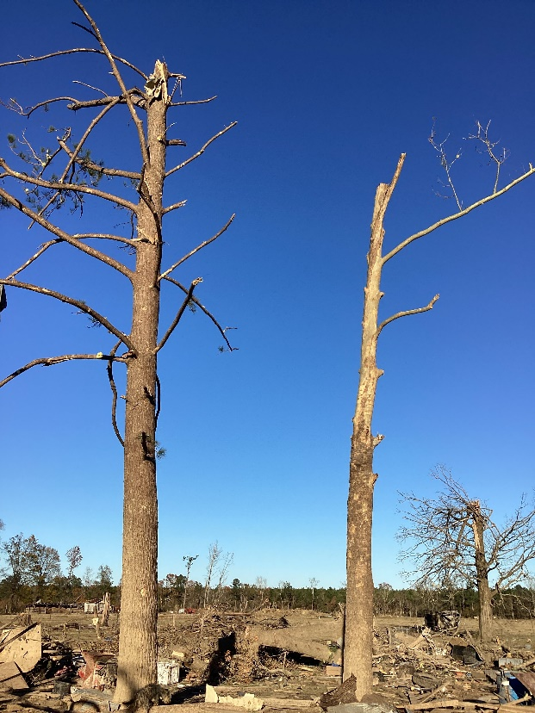
From this location the tornado continued on roughly 3.5 miles east northeast before crossing Wyant Road near the Twelve Mile Post Road intersection. The survey team did not have road access in this 3.5 mile span before this road, but used available drone footage to confirm significant swaths of tree damage in this gap. Only tree damage was observed along Wyant Road, but the high level of tree snapping was enough to confirm EF2 strength here. From here the tornado continued on down Wyant Road, which had turned northeast to crisscross the tornado’s path through hillier terrain. The tornado damage showed a tendency for the tornado to narrow and weaken at times through the terrain, but it did continue without lifting until reaching the Ouachita River. Along the southwestern bank of the river there were two homes which received heavy damage and several outbuildings which were totally destroyed with debris thrown into the river. The tornado crossed the river and did significant tree damage along Lee Lane. From there the tornado continued east-northeast while gradually narrowing and weakening, crossing Highway 559. Based on downed trees and additional information from satellite, the track was extended slightly farther east after crossing Parish Road 6625.
Figure 13 - Trees Debarked

While the tornado lifted upon crossing the Ouachita River, the circulation aloft remained as it moved into Franklin Parish toward the Winnsboro area. By 6:30 PM it crossed Winnsboro and headed toward Madison Parish. A tornado warning remained in effect for portions of Franklin, Madison, and Tensas Parishes.

At 7:01 PM CST, the storm produced one final brief tornado touchdown in Madison Parish just prior to the storm crossing into Mississippi. The tornado was photographed by storm chasers after being illuminated by lightning strikes. It was located in a field between Tallulah and Mound just off of Thomastown Road. National Weather Service survey teams did not find any damage due to the fact the tornado touched down in an open field. However, because it was documented with video evidence, it was rated as an EF-U with “U” being for unknown intensity.

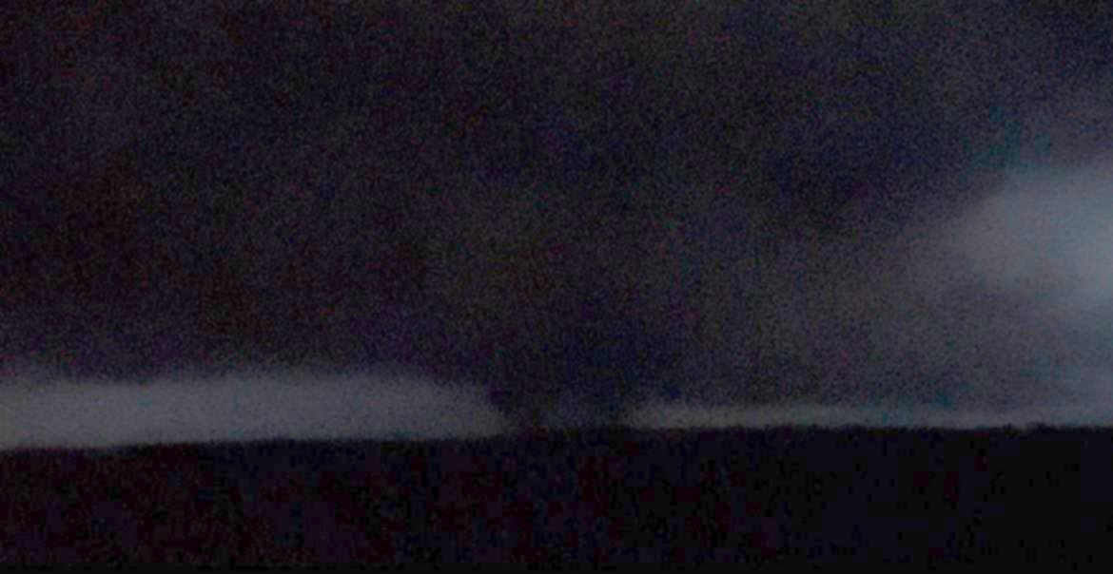
Figure 14 - Madison Parish Tornado (EF-U) Captured by Storm Chasers (source unknown). Photo Provided by Malmay and Associates

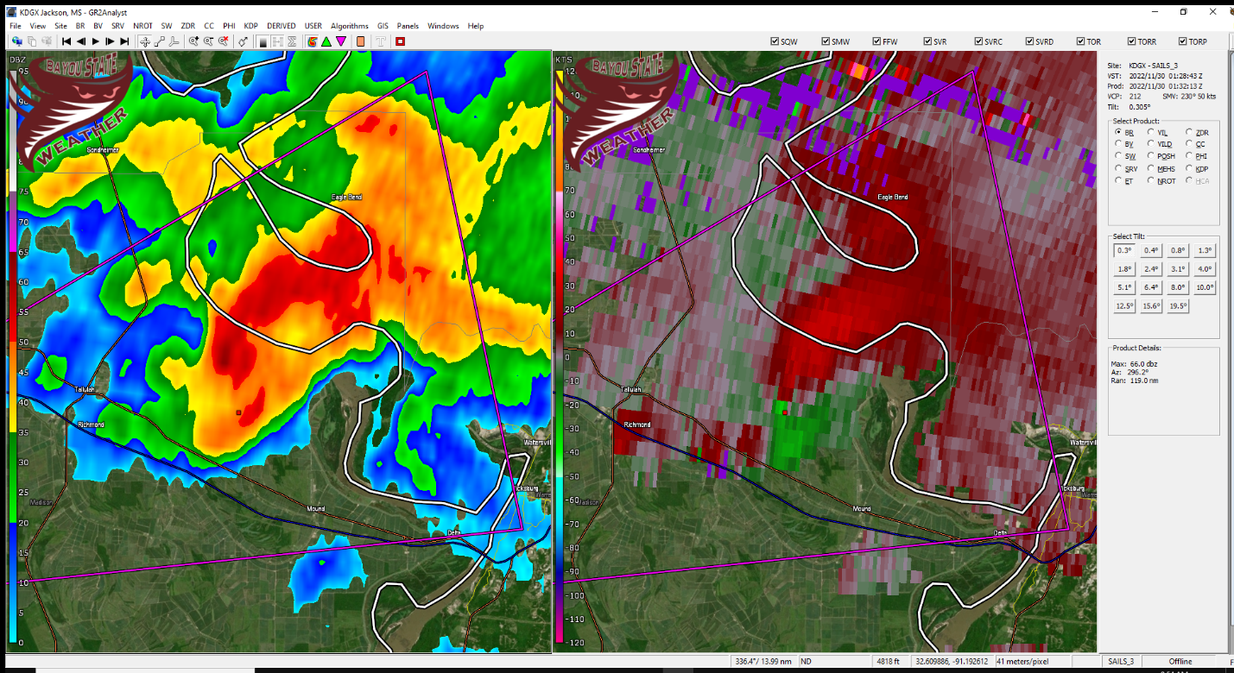
Figure 15 - Radar Image from Jackson, MS NWS of the Madison Tornado
The storm continued northeast crossing into Mississippi. While no additional confirmed tornadoes were reported, tornado warnings continued with the storm into central Mississippi. The long-tracked supercell of nearly 260 miles was absorbed with a cluster of storms northeast of Yazoo City near the town of Durant at around 0300Z/9:00 PM CST lasting some seven hours!

Late in the evening, the cold front that was poised to the northwest across southwest Arkansas into northeast Texas, finally began to push southeast. A line of showers and thunderstorms developed along the front sweeping across north Louisiana during the late evening through the early post-midnight hour. These storms were sub-severe but did produce locally heavy rainfall and gusty winds of 30 to 50 mph with their passage.

Summary

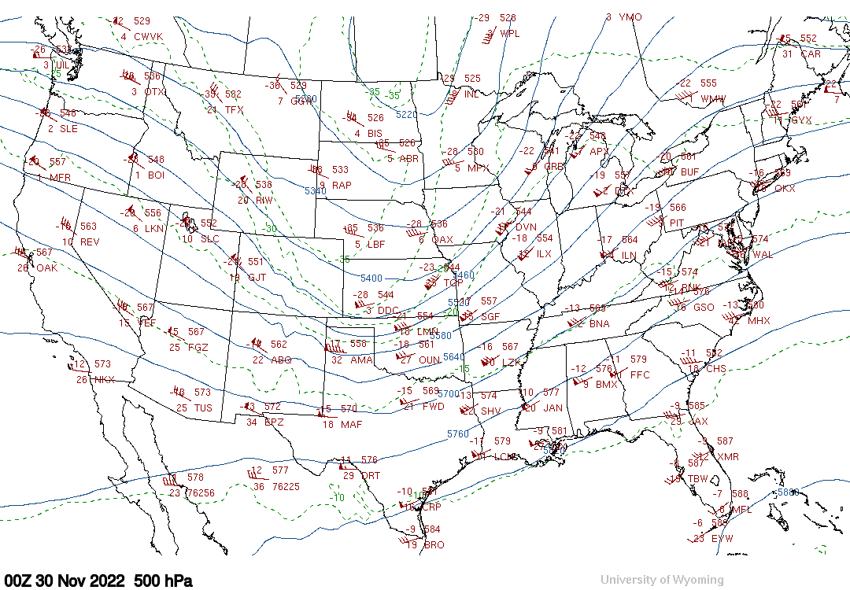
A potent storm system brought the threat for severe weather to much of north Louisiana which included a PDS-Tornado Watch. Numerous tornado warnings were issued with this event; however, it only produced two confirmed tornadoes, one of which was a strong tornado rated as an EF-3 with maximum winds of 140 mph. Many of the ingredients were in place for a more significant outbreak across north and central Louisiana but that region was on the western extent of the most unstable environment. The lack of daytime heating due to cloud cover likely played some role in quelling a more significant and widespread outbreak. It is also likely, based upon the two axes of storm tracks, that some upper-level guidance was at play given that we did have an increasing southwesterly flow coming in from the south while a large-scale trough was advancing east from the Plains states. In addition, the cold front that was poised to our northwest was hesitant to push southeast and did not do so until late in the evening of the 29th and thus played a minimal role in the severe weather. These possibilities would need to be further analyzed in a more scientific study.
Figure 16 - Upper Level 500mb Chart at 0000Z/6:00 PM CST 12/29/2022 or 12/30/2022 (Z)

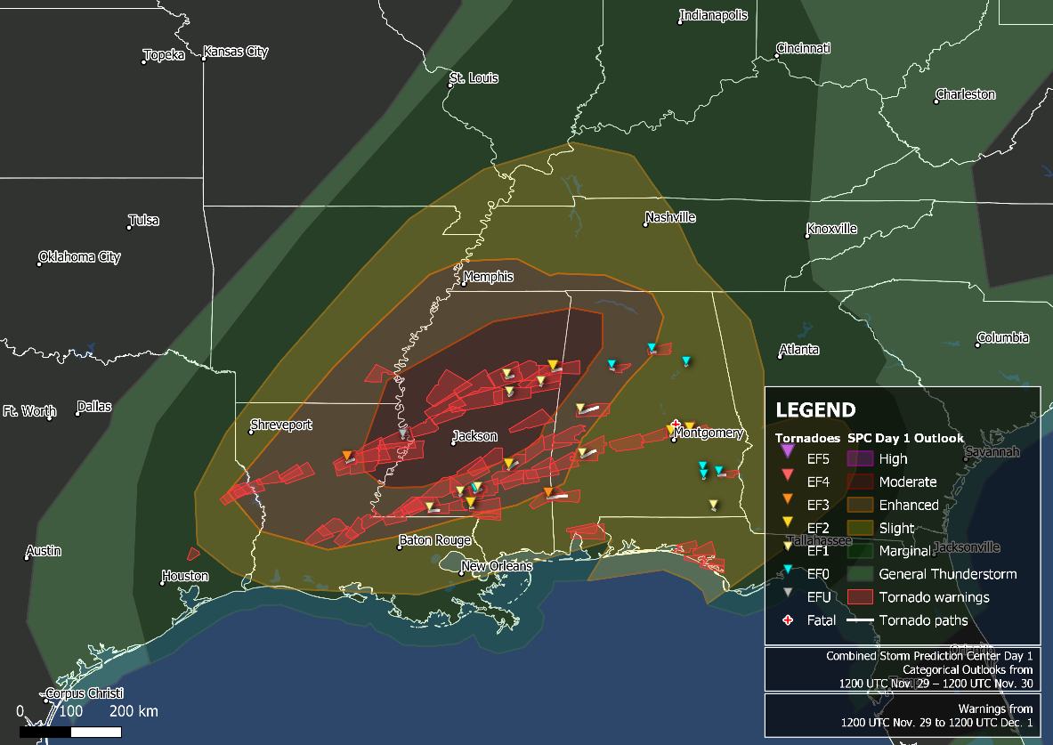
Figure 17 - Map Depicting Tornado Warnings

Images*

*Damage images courtesy of the National Weather Service in Shreveport, Louisiana. These images are from the EF-3 Caldwell Tornado.

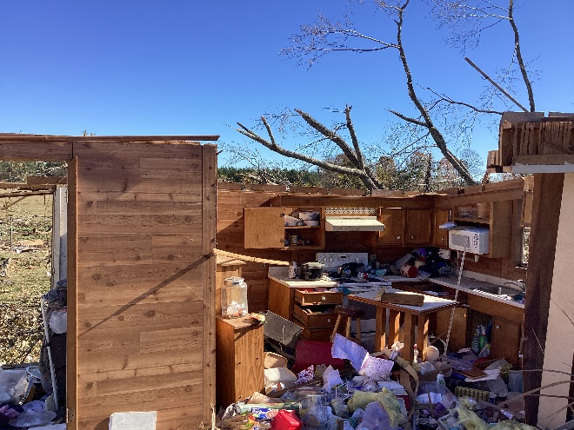 | 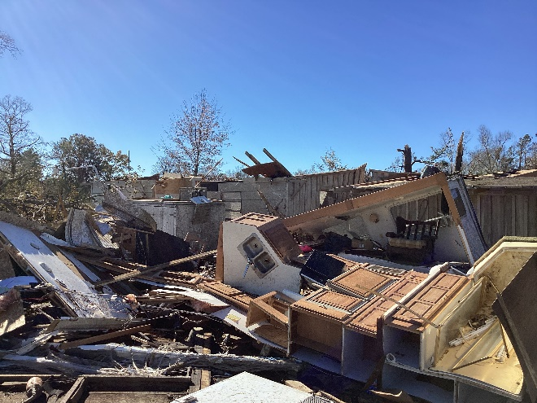
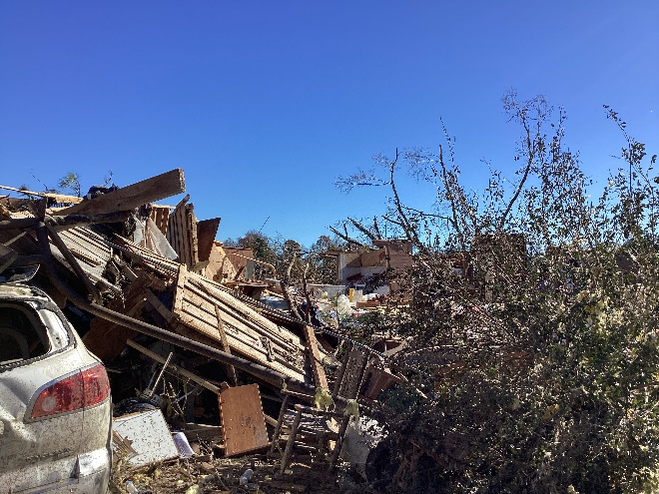 | 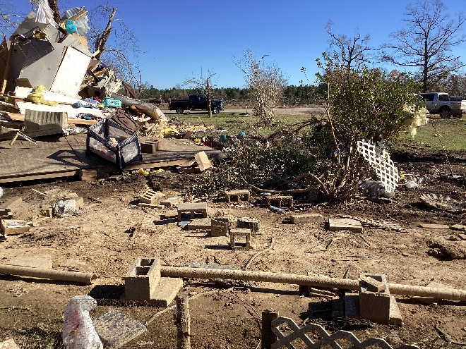
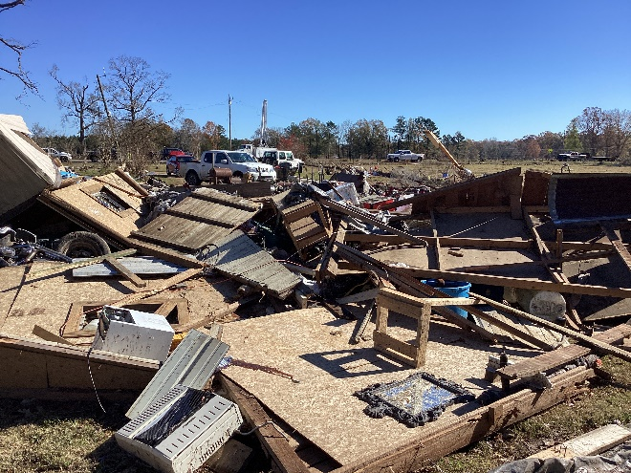 | 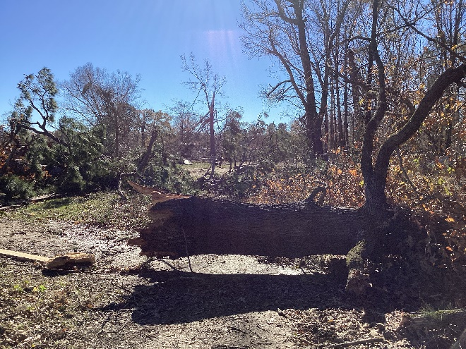
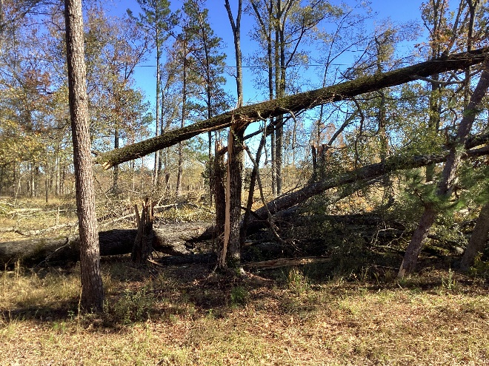 | 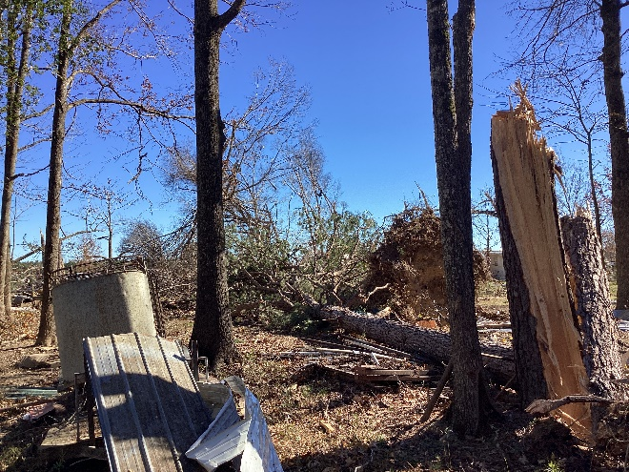
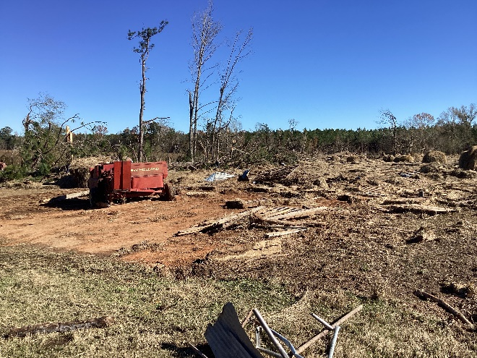 | 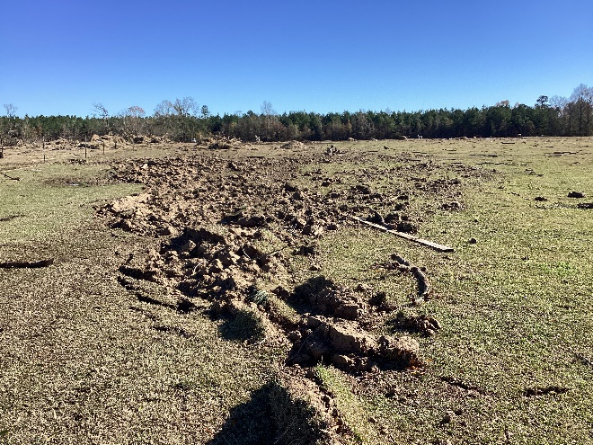
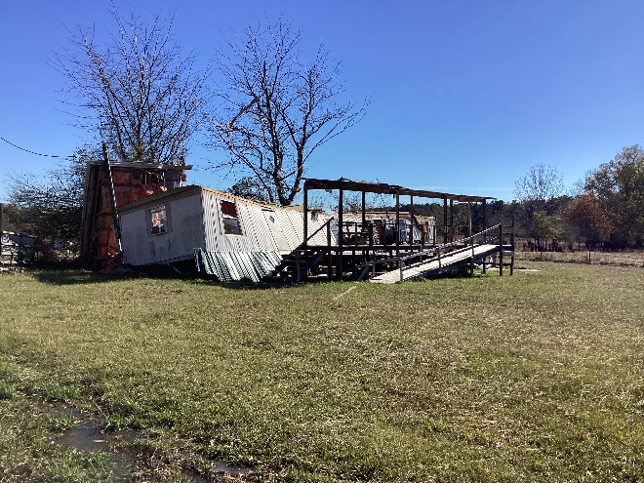 | 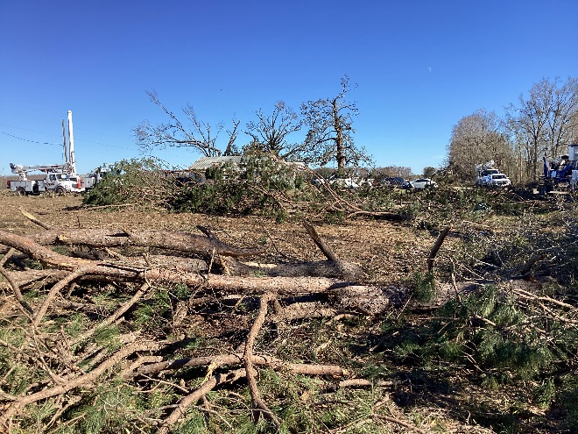
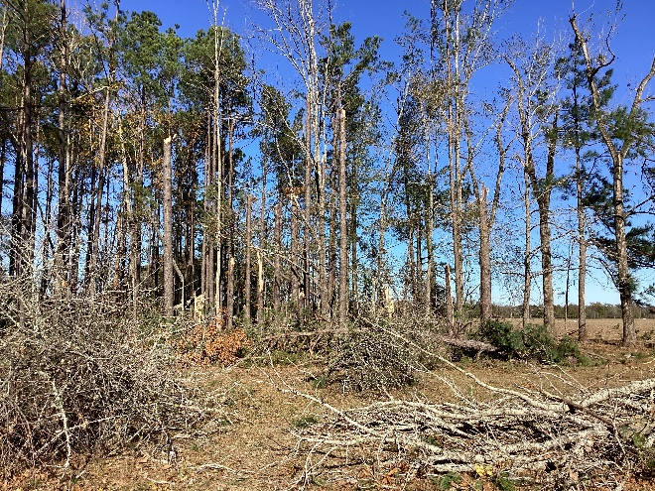 | 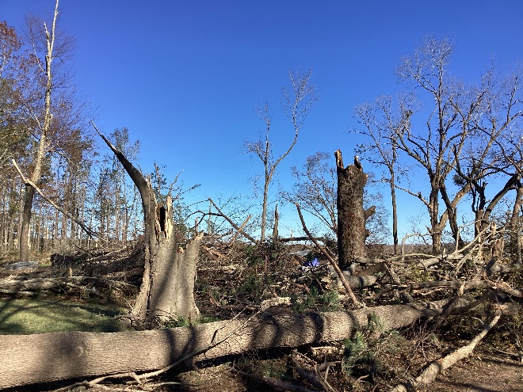

Acknowledgements

Bayou State Weather, LLC

Iowa State University

Malmay and Associates, LLC

National Weather Service – Shreveport, Louisiana

Storm Prediction Center – Norman, Oklahoma

University of Wyoming

